# Visitors can perform the follow actions:

### add a user

End Point: <http://localhost:7777/user>

Request:

{

"userId": 1,

"firstName": "Darshan Madappa",

"lastName": "G B",

"email": "maddy@GMAIL.COM",

"mobile": "512-968-9999"

}

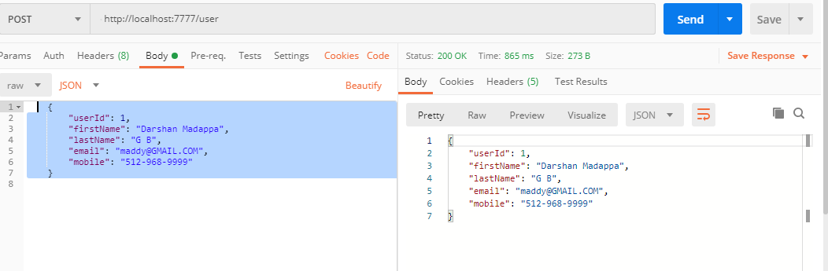

User already exists

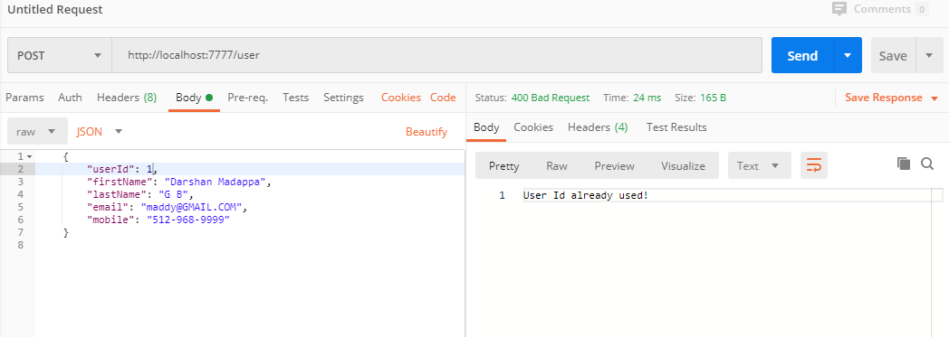

Get all users

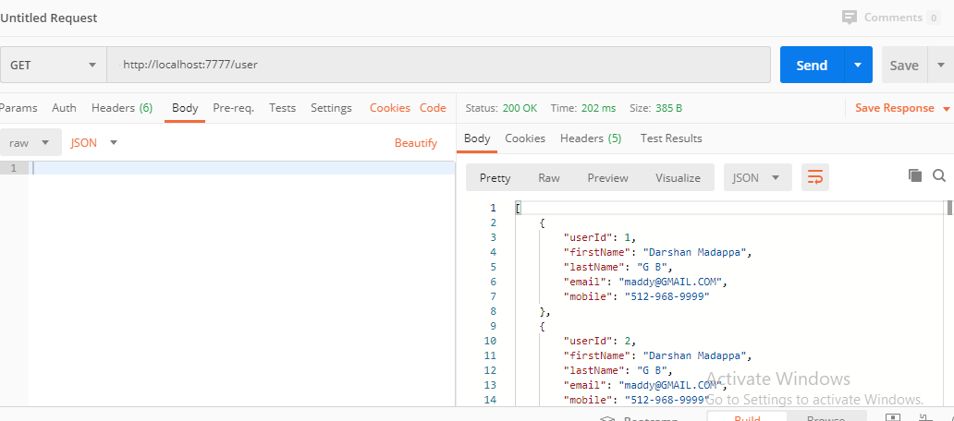

### Allows to delete an existing user

Endpoint: **DELETE** <http://localhost:7777/user/1>

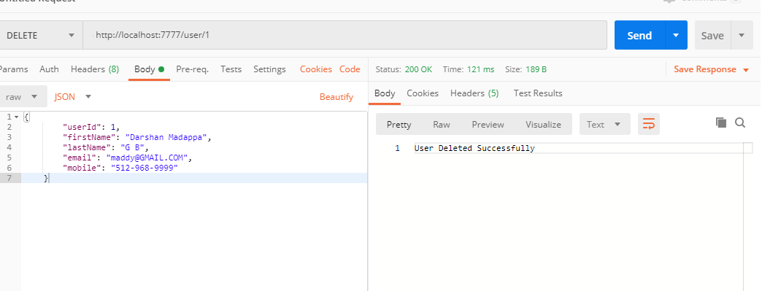

### Allow to add interview

Endpoint: **POST** <http://localhost:7777/interview>

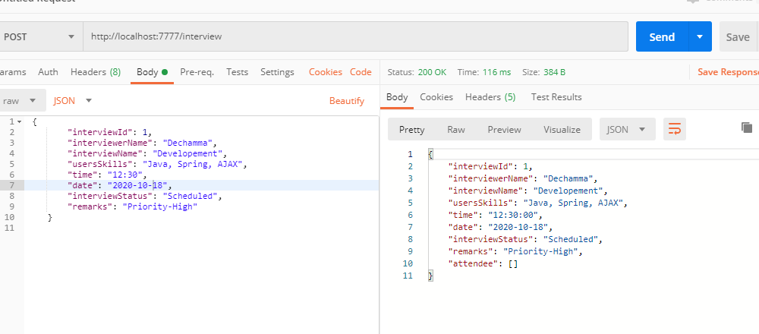

### Allow to delete an existing interview

Endpoint: **DELETE** <http://localhost:7777/interview/1>

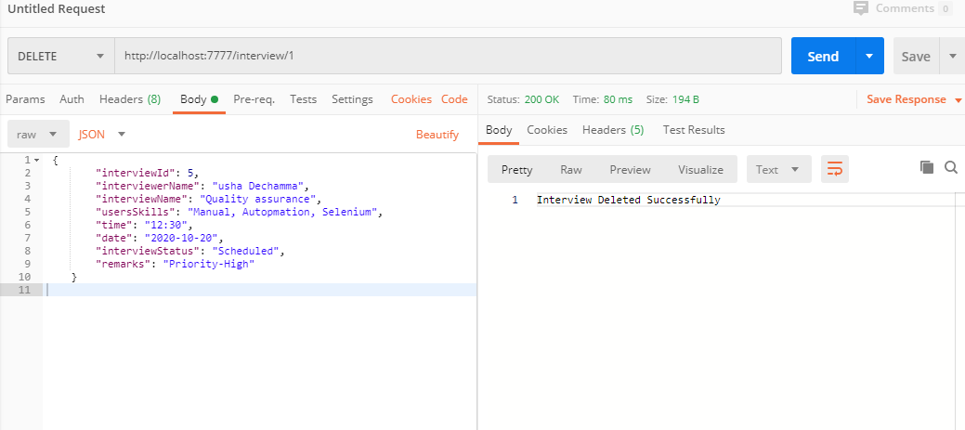

### Allows searching total no of count of interview.

End point: **GET** <http://localhost:7777/interview/count>

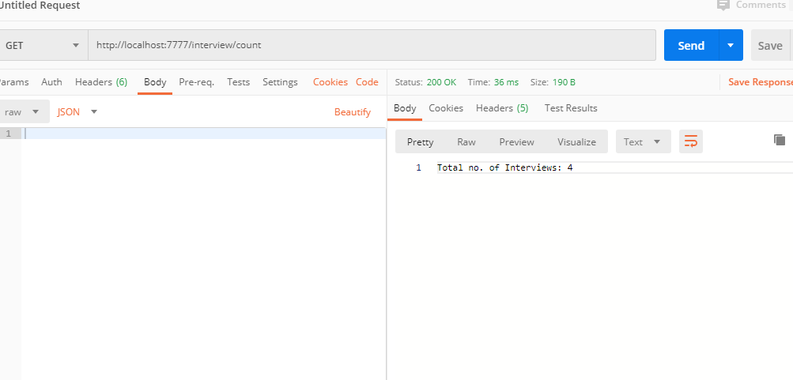

### Allows to display all the interviews

Endpoint: **GET** <http://localhost:7777/interview/showInterviews>

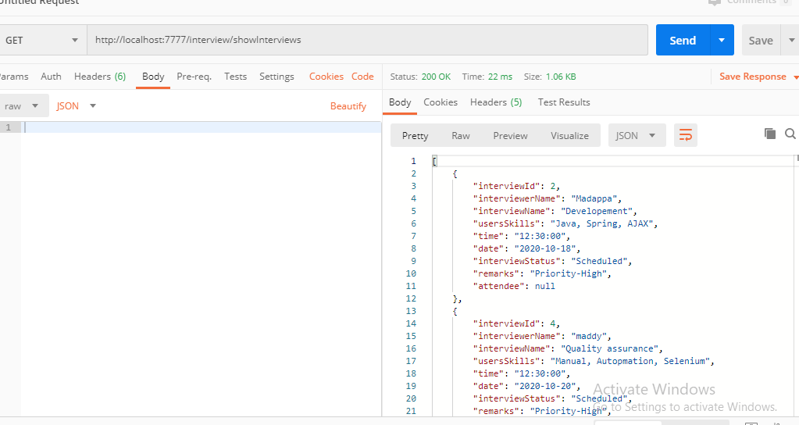

### Allow to add attendee to an interview

Add user as attendee to new interview

Endpoint: **POST** <http://localhost:7777/interview>

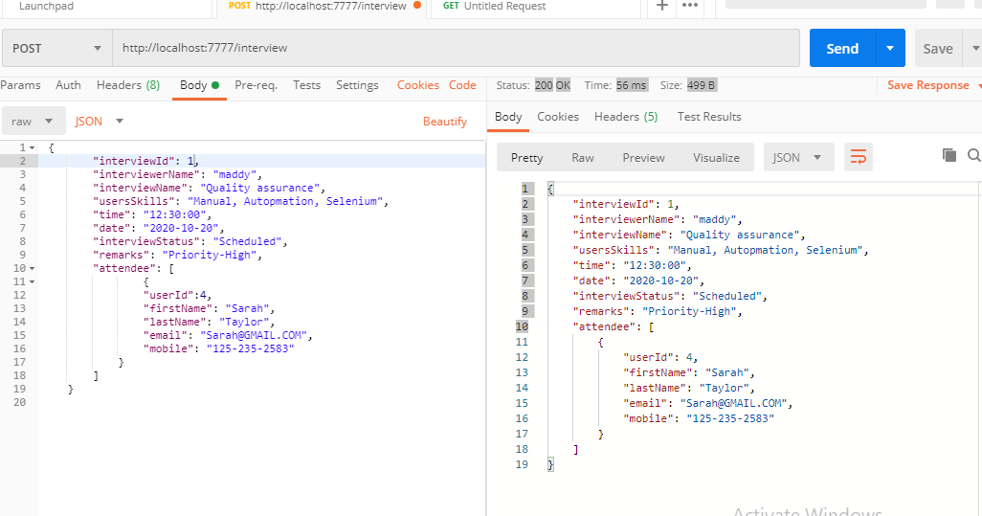

# Assumptions, Dependencies, Risks / Constraints:

### While adding a user to interview as attendee, if user id already exists, it should throw a custom exception.

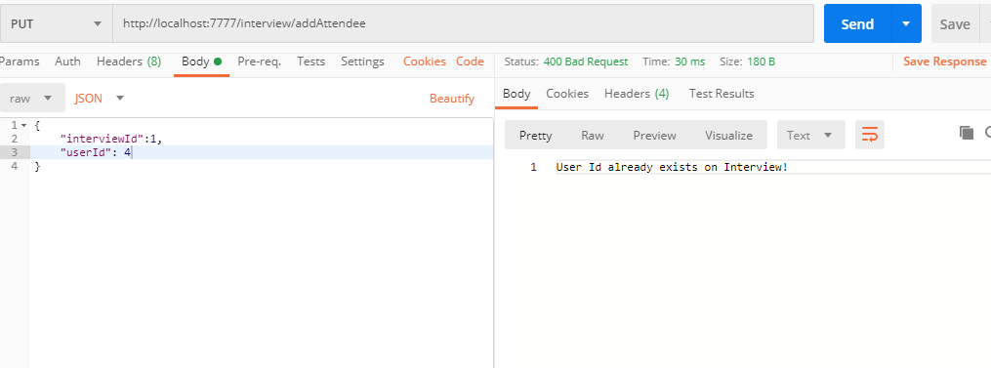

### While deleting the user and interview also, assumed that id already exists, else throw an custom exception

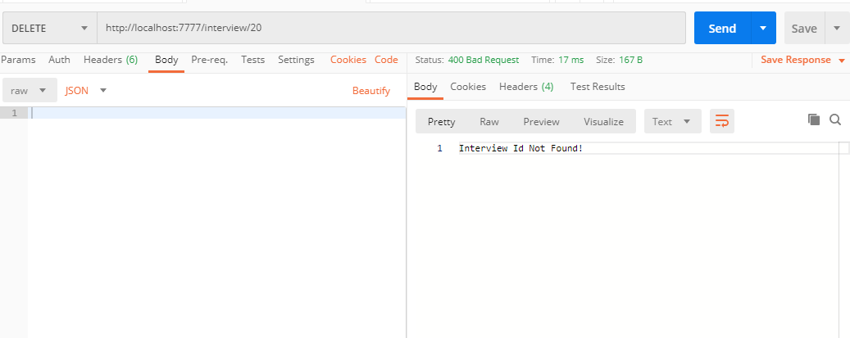

# MySQL Schema

mysql> drop database ITSDB;

Query OK, 3 rows affected (0.72 sec)

mysql> create database ITSDB;

Query OK, 1 row affected (0.09 sec)

mysql> use ITSDB;

Database changed

